HOW TO GET TO IPO VENUE – VIA VEIENTANA N.386
FROM FIUMICINO AIRPORT LEONARDO DA VINCI TO TERMINI TRAIN STATION
To take Train “Leonardo Express” Ticket Euro 14.00. This is the standard way to get into the city from the airport.
FROM TERMINI TRAIN STATION TO IPO VENUE
To take Subway line A (towards “Battistini”) until a station “Flaminio”. It should take ca. 10 minutes from Termini to Flaminio.
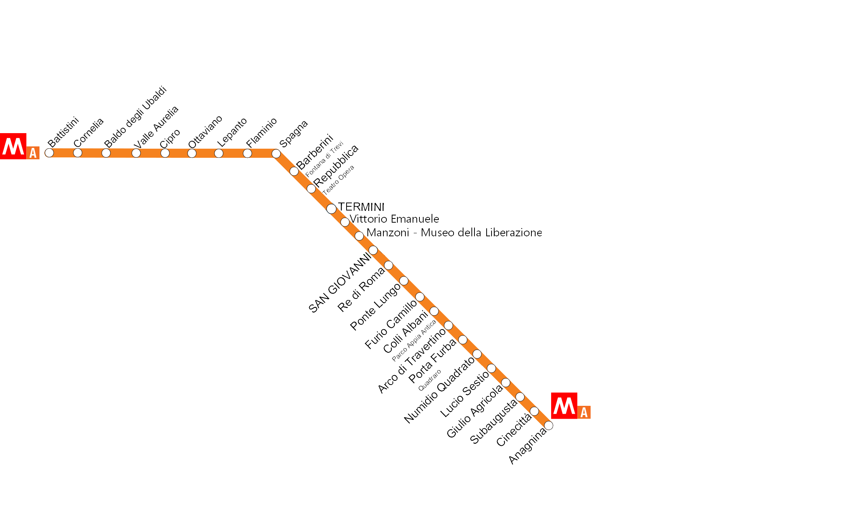
To take Railway line Roma-Viterbo – Train stop “Prima Porta”. It should take ca. 20 minutes.
To take Bus number 303 – Bus stop Giustiniana crossing with Via Veientana
OR
To take Railway line Roma-Viterbo – Train stop Saxa Rubra – Taxi stop

